**PERCUSSION PERFORMANCE ASSIGNMENT** #1

Play from memory

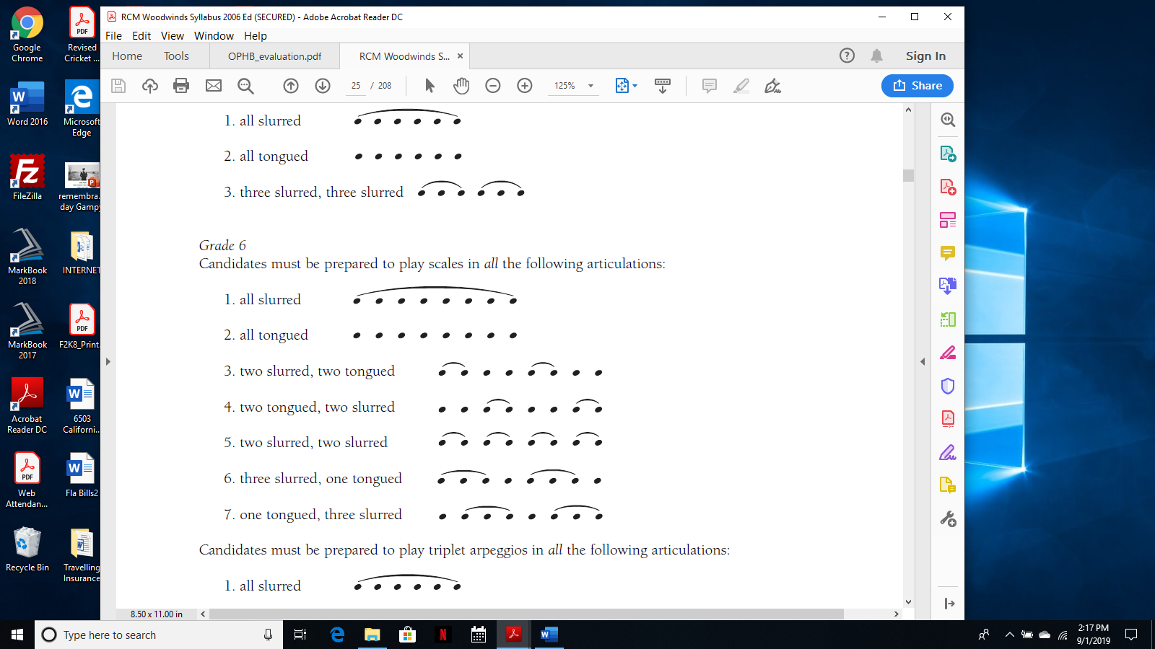



|  |  |  |  |
| --- | --- | --- | --- |
| **KNOWLEDGE** | 01. Posture: Head/Shoulders/Arms/Feet | 8 |  |
| (Presentation) | 02. Hand Positions/Holding Instrument | 8 |  |
|  | 03. Memory | 9 |  |
| **THINKING** | 04. Embouchure | 8 |  |
| (Mechanics) | 05. Articulation | 8 |  |
|  | 06. Breath Support | 9 |  |
| **APPLICATION** | 07. Pitch Accuracy-fingerings | 8 |  |
| (Musicianship) | 08. Rhythmic Accuracy | 8 |  |
|  | 09. Tempo Consistency | 9 |  |
| **COMMUNICATION** | 10. Dynamic Contrast | 8 |  |
| (Musicality) | 11. Phrasing | 8 |  |
|  | 12. Tone Quality | 9 |  |